FRECCE DIREZIONALI SOTTO LA TABELLA.

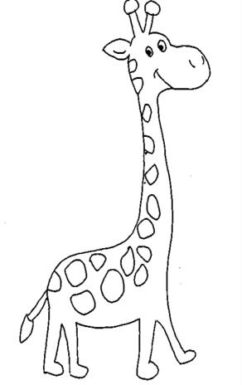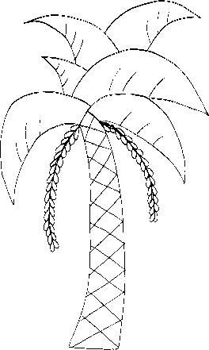

|  |  |  |  |  |  |  |
| --- | --- | --- | --- | --- | --- | --- |
|  |  |  |  |  |  |  |
|  |  |  |  |  |  |  |
|  |  |  |  |  |  |  |
|  |  |  |  |  |  |  |
|  |  |  |  |  |  |  |
|  |  |  |  |  |  |  |
|  |  |  |  |  |  |  |

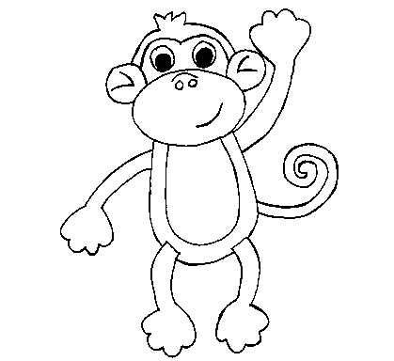FRECCE DIREZIONALI TRACCIA TU QUESTA VOLTA UN PERCORSO CORRETTO, POI COLORA.

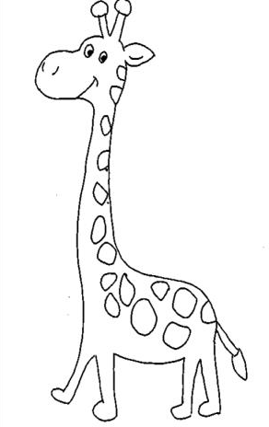

|  |  |  |  |  |  |  |
| --- | --- | --- | --- | --- | --- | --- |
|  |  |  |  |  |  |  |
|  |  |  |  |  |  |  |
|  |  |  |  |  |  |  |
|  |  |  |  |  |  |  |
|  |  |  |  |  |  |  |
|  |  |  |  |  |  |  |
|  |  |  |  |  |  |  |

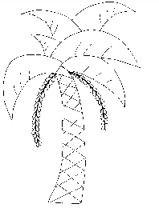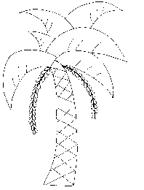EVITANDO LUNGO IL PERCORSO LE PALME, INFINE COLORA.



              
              
              
              
              
              
              
              
              