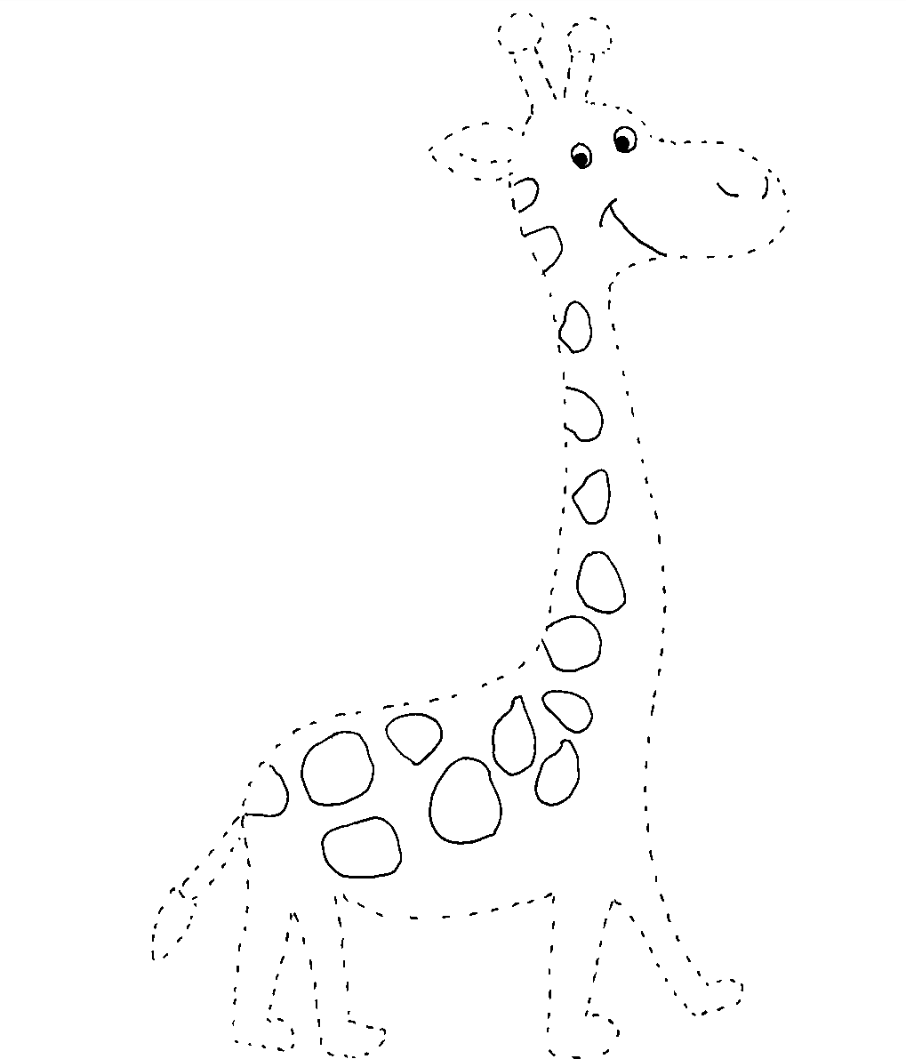

|  |  |  |  |  |  |  |  |  |  |  |  |  |  |  |  |  |  |  |
| --- | --- | --- | --- | --- | --- | --- | --- | --- | --- | --- | --- | --- | --- | --- | --- | --- | --- | --- |
| **L** | **A** |  | **G** | **I** | **R** | **A** | **F** | **F** | **A** |  | **V** | **A** | **N** | **I** | **T** | **O** | **S** | **A** |
|  |  |  |  |  |  |  |  |  |  |  |  |  |  |  |  |  |  |  |

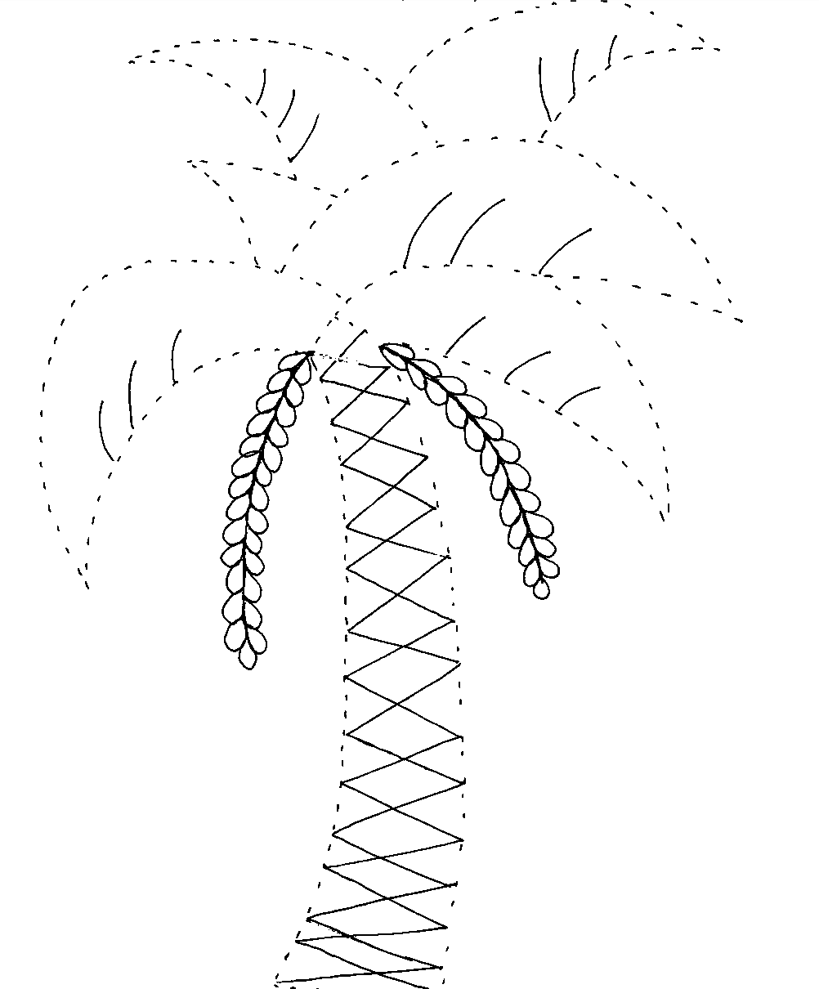

|  |  |  |  |  |  |  |  |  |  |  |  |  |  |  |  |  |
| --- | --- | --- | --- | --- | --- | --- | --- | --- | --- | --- | --- | --- | --- | --- | --- | --- |
| **I** |  | **D** | **A** | **T** | **T** | **E** | **R** | **I** |  | **S** | **U** | **C** | **C** | **O** | **S** | **I** |
|  |  |  |  |  |  |  |  |  |  |  |  |  |  |  |  |  |

CON FILI DI LANA.

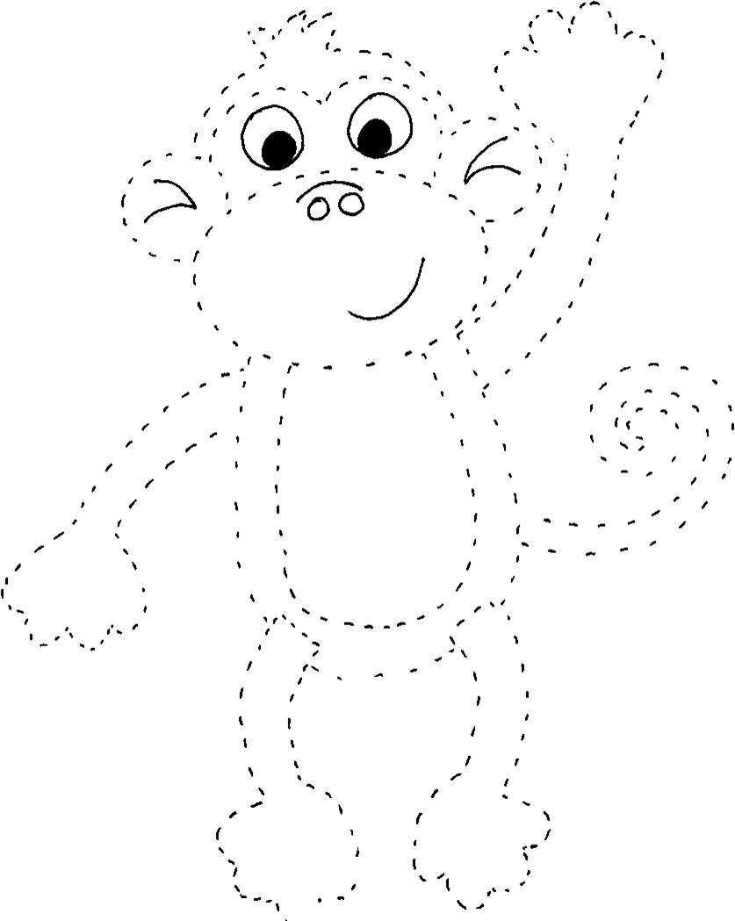

|  |  |  |  |  |  |  |  |  |  |  |  |  |  |  |  |  |  |  |  |  |
| --- | --- | --- | --- | --- | --- | --- | --- | --- | --- | --- | --- | --- | --- | --- | --- | --- | --- | --- | --- | --- |
| **L** | **A** |  | **S** | **C** | **I** | **M** | **M** | **I** | **A** |  | **G** | **I** | **U** | **D** | **I** | **Z** | **I** | **O** | **S** | **A** |
|  |  |  |  |  |  |  |  |  |  |  |  |  |  |  |  |  |  |  |  |  |

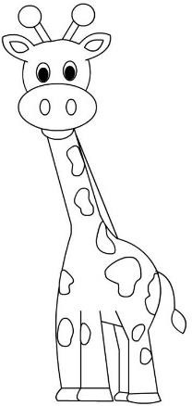NOME, SCRIVI IL NUMERO SOTTO LA PAROLA E COLORA.

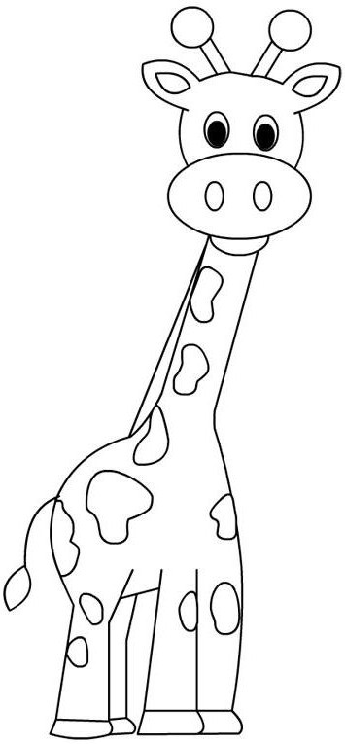

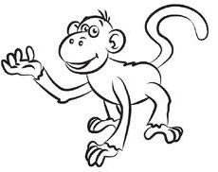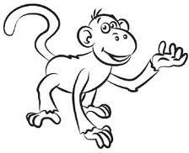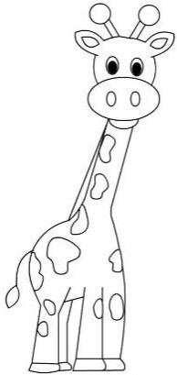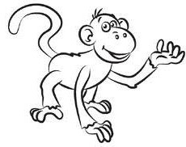

|  |  |  |  |  |  |  |
| --- | --- | --- | --- | --- | --- | --- |
| **G** | **I** | **R** | **A** | **F** | **F** | **A** |
|  |  |  |  |  |  |  |

|  |  |  |  |  |  |  |
| --- | --- | --- | --- | --- | --- | --- |
| **S** | **C** | **I** | **M** | **M** | **I** | **A** |
|  |  |  |  |  |  |  |

**………………….**

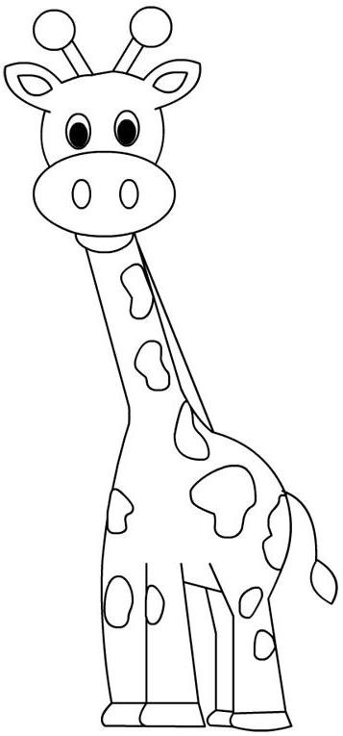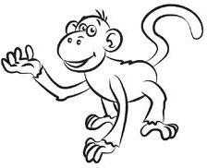

………………….

NELL’ESEMPIO.

1

5

10

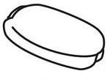

8

3

4